## CHAPTER 1

## INTRODUCTION

5G Arena aims to evaluate the online presence and functionality of 5G Arena, a platform that offers a wide range of Mobiles from various manufacturers to meet the diverse needs of mobile buyers. The purpose of this website is to provide a comprehensive analysis of the website's key features, including its user interface and navigation, product offerings, customer reviews and ratings, financing options, and customer service and support.

It will also offer recommendations on how the website can improve its overall performance and provide a better user experience for customers. By analyzing the website's strengths and weaknesses, this report will serve as a valuable resource for both the mobile dealership and potential mobile buyers. It aims to provide an in-depth analysis of the website and its ability to meet the needs and expectations of its customers.

It analyzes the advantages and potential areas for improvement of the website, providing valuable insights for both the mobile dealership and its customers. It also gives the user the freedom to choose his desired page without any restrictions . By evaluating the website's ability to meet the needs and expectations of customers, it aims to provide recommendations on how the website can better serve its audience.

### PROBLEM STATEMENT

The smartphone industry is rapidly evolving, and mobile dealers are facing increasing pressure to provide a seamless and convenient online shopping experience for customers. Despite the growing importance of online mobile shopping, many mobile sales websites are not optimized to meet the needs and expectations of today's mobile buyers.

### OVERVIEW

The 5G Arena is a mobile sales platform that offers a wide range of mobiles from various manufacturers to meet the diverse needs of mobile buyers. The website aims to provide a convenient, efficient, and informative mobile buying experience for customers, helping the customer to choose which mobile is best suited for their requirements and expectations.

### OBJECTIVE

The objective of this report is to evaluate the 5G Arena, a mobile sales platform, and provide recommendations for enhancing its online capabilities and customer experience. This includes analyzing the website's user interface and navigation, product offerings, customer reviews and ratings, financing options, and customer service and support. The ultimate goal is to identify areas for improvement and provide insights to help the website better serve its customers and drive sales.

## CHAPTER 2

## SYSTEM SPECIFICATION

In this chapter, we are going to see the softwares that we have used to build the website. This chapter gives you a small description about the softwares used in the project.

### 2.1 VS CODE

Visual Studio Code is a source code editor developed by Microsoft for Windows, Linux, and macOS. It includes support for debugging, embedded Git control, syntax highlighting, intelligent code completion, snippets, and code refactoring..

Visual Studio Code includes a powerful auto-complete feature, which suggests code as the developer types, reducing the likelihood of syntax errors. The editor also includes linting and debugging tools, allowing developers quickly identify and fix coding issues. It has built-in support for JavaScript, and enables developers to quickly move between files and view detailed type definitions. It also has a built-in terminal for running tasks.

Visual Studio Code is a popular code editor that is widely used by web developers for HTML and CSS development. It provides a user-friendly interface with a variety of that make coding easier and more efficient. Visual Studio Code includes a powerful auto-complete feature, which suggests code as the developer types, reducing the likelihood of syntax errors. The editor also includes linting and debugging tools, allowing developers quickly identify and fix coding issues. In addition, Visual Studio Code supports a variety extensions and plugins that can be used to enhance its functionality.

### LOCAL STORAGE

Local storage is a type of web storage for storing data on the client side of a web browser. It allows websites to store data on a user’s computer, which can then be accessed by the website again when the user returns. Local storage is a more secure alternative to cookies because it allows websites to store data without having to send it back and forth with each request. Local storage is a key-value pair storage mechanism, meaning it stores data in the form of a key and corresponding value. It is similar to a database table in that it stores data in columns and rows, except that local storage stores the data in the browser rather than in a database. Local storage is often used to store user information such as preferences and settings, or to store data that is not meant to be shared with other websites. It is also used to cache data to improve the performance of a website. Local storage is supported by all modern web browsers, including Chrome,

Firefox, Safari, and Edge. It is accessible through the browser’s JavaScript . Local storage is a powerful tool for websites to store data on the client side. It is secure, efficient, and can be used to store data that does not need to be shared with other websites.

## CHAPTER 3

## PROPOSED SYSTEM

This chapter gives a small description about the proposed idea behind the development of our website

### PROPOSED SYSTEM

Based on the analysis and evaluation of the 5G Arena mobile sales platform, the following recommendations are proposed to improve the online customer experience and drive sales. Enhance User Interface and Navigation: The website's user interface should be modern, intuitive, and user-friendly, making it easy for customers to find the information and features they need. The navigation should be clear and straightforward, with categories and filters to help customers quickly find the mobiles they are interested in.

The website should offer a wide range of latest mobiles from various manufacturers, with detailed information and photos for each mobile. The website should also incorporate customer feedback and ratings to improve the quality and presentation of its product offerings.

The financing options should be integrated into the mobile buying process, allowing customers to complete the entire process on the website. The website should offer various channels for customers to get help and support, including online chat, FAQs, and contact information. The customer service and support should be responsive, helpful, and accessible to meet the needs of customers.

### ADVANTAGES

* Convenience: A mobile sales website offers the convenience of shopping for a mobile from the comfort of one's home which can also act as a useful mobile buying guide.
* Increased Product Visibility: A well-designed website showcases the mobile’s entire specifications providing customers with a comprehensive view of all the available mobiles.
* Time-saving: With a mobile sales website, customers can save time by researching and comparing mobiles online before visiting the dealership in person.
* Improved Customer Service: A mobile sales website can provide customers with instant access to support and information.
* Online Financing Options: Many sales websites offer online financing options, allowing customers to easily apply for financing and receive pre-approval before making a purchase.

## CHAPTER 4 METHODOLOGIES

### 4.1.LOGIN

In this page we will be asking about the username and password of the user. Firstly the website validates the user inputs. It verifies the username and password by checking it with the usernames and passwords stored in the local storage when the user creates an account in the website.

**4.2.SIGNUP PAGE**

This page asks users about the basic details of the user to create an account. This page asks for details like username, password , email id, phone number. After the user enters the details , these details are then validated by our code . If all details are correct then the user is then directed to the login page.

### 4.3 MOBILES PAGE

This page displays the list of products available for sale. These details have been displayed from the list of products available in the javascript file named data.js. So that if we want to add some products to a particular product we can easily do it by adding the details to the products js file.

### 4.4 PAYMENT PAGE

In this page you can complete the payment for the mobile. This is the final page of the website where you are able to pay for the mobile buying and have a receipt of it. Here you must enter the essential details for the processing of payment so careful while giving the credentials. This page requires name of the card holder, DOB, card number, expiry date.

### CHAPTER 5

### IMPLEMENTATION AND RESULT

This chapter gives a description about the output that we produced by developing the website of our idea.

### 5.1 LOGIN

When User enters our website he will be asked about his login details like email id and password. The login details will be verified with the details given while the user creates an account. The user needs to sign in in order to buy the mobiles.

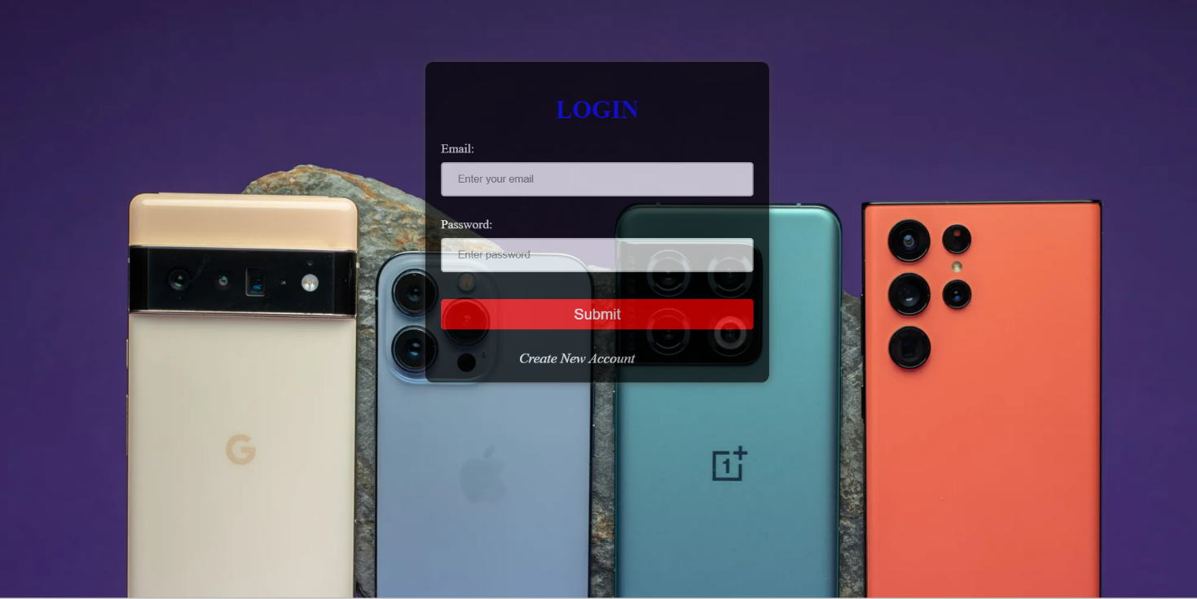

**Fig 5.1 LOGIN PAGE**

### 5.2 SIGN UP

If a user doesn’t have an account on the website, User can use a component named create new account available in the login page. When the user clicks on that he will be redirected to the signup page. In sign up he should fill up his email id, password and phone number. These inputs will be validated. If the given inputs are wrong , the details must be filled again in the fields respectively.

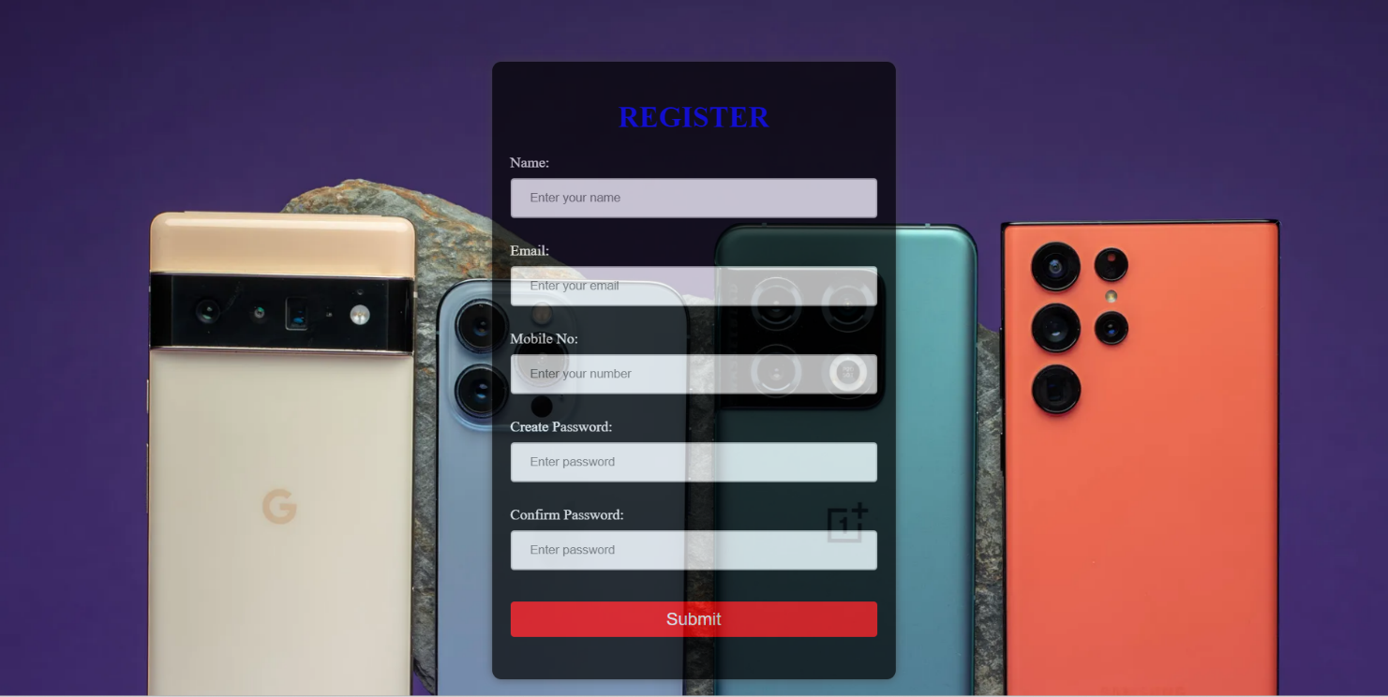

**Fig 5.2 SIGNUP PAGE**

### 5.3 MOBILES PAGE

Here the latest mobiles available in the market are given.. If you are interested you may buy the mobile. Here you may view the description of the mobile we have. You may redirect to the home page using the navigation bar on the top easily. The mobiles page gives you the overview of the cars we currently have at stock and can be booked by the customers. To see more details about the mobile like manufactured year, price you may click the more option to view more about the mobiles given.

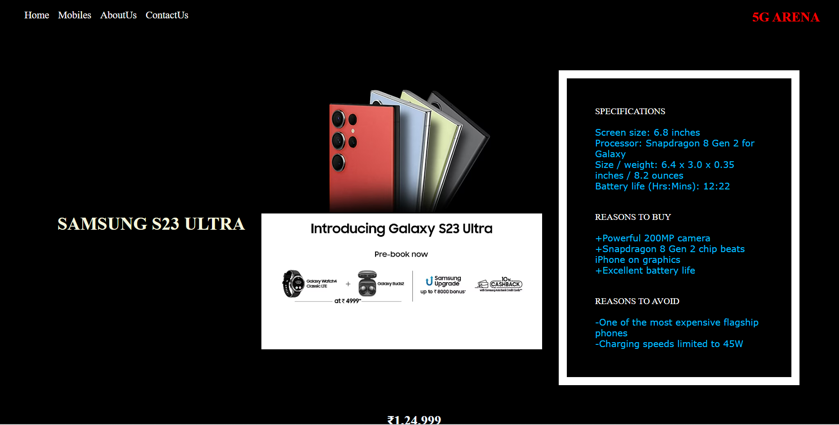

**Fig 5.3 MOBILES PAGE**

### 5.4 HOME PAGE

The webpage has different categories of mobiles available for sale and users can redirect to the mobiles description page by selecting the respective links. This page also contains the main taglines of the whole website idea. From the home page you can access all the pages of the website. You can access the about us page and even contact us page for any queries and complaint. Home page is the main page which connects all other pages like mobiles, login, about us, contact us. To view the mobiles you may click the to explore button in the home page or you may click the mobiles option in the navigation bar.

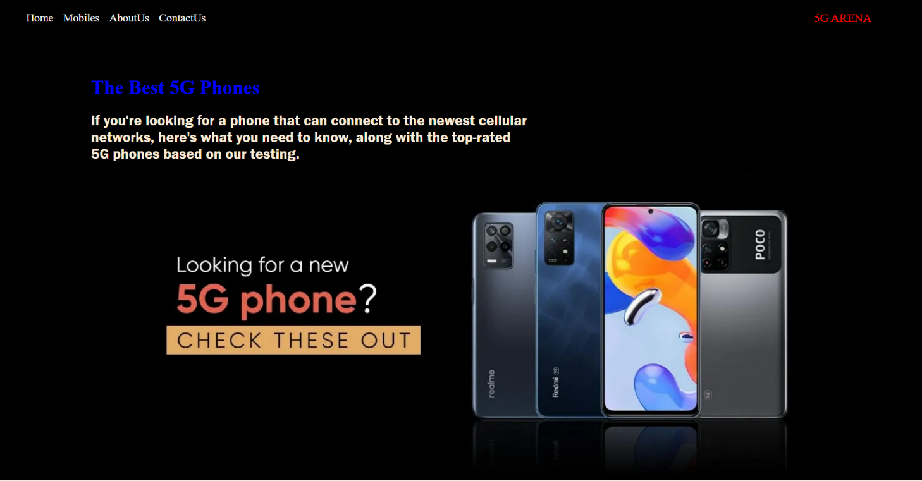

**Fig 5.4 HOME PAGE**

### 5.5 PAYMENT PAGE

In this page you can finish the final step of the website. You can place order for the mobile by paying the advance amount here. Enter the required details correctly . So that the payment won’t go wrong . If you type the details wrong and made a payment the company won’t be responsible. This page requires details like name of the card holder, date of birth of the card holder to avoid any problems, card number of the account which will be processed for payment , expiration month and expiration year to verify the card. After processing these details your details will be checked and the ordering is complete.

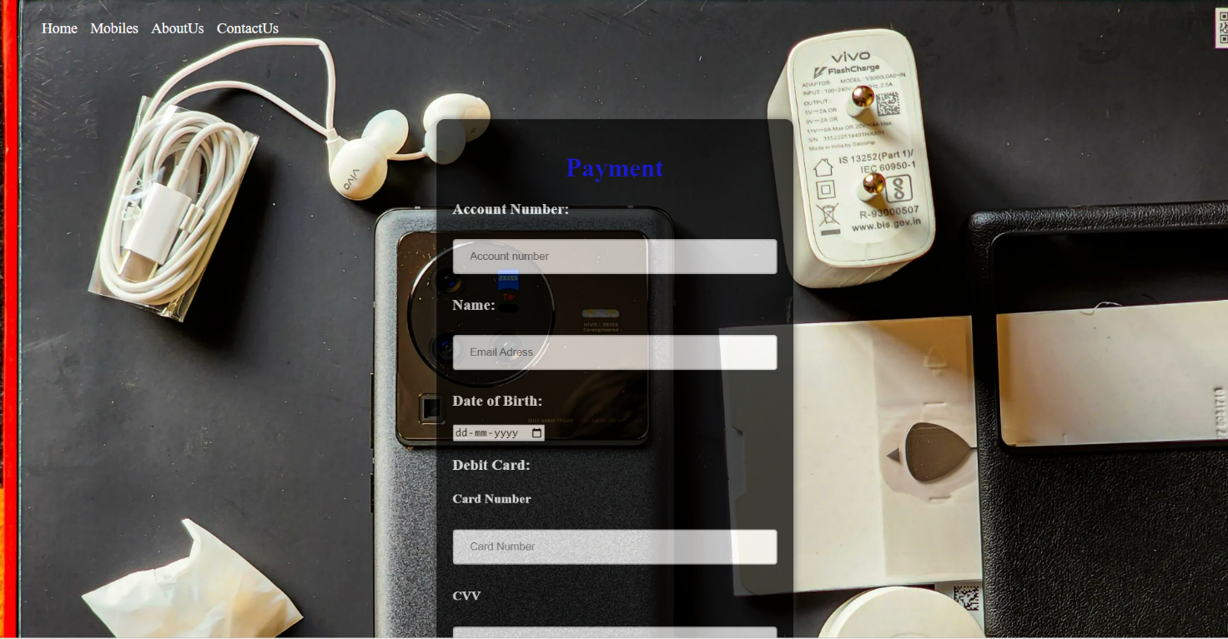

**Fig 5.6 PAYMENT PAGE**

### 5.6 CODING

**LOGIN:**

**HTML**:

<!DOCTYPE html>

<html lang="en">

<head>

<meta charset="UTF-8">

<meta http-equiv="X-UA-Compatible" content="IE=edge">

<meta name="viewport" content="width=device-width, initial-scale=1.0">

<title>Document</title>

<link rel="stylesheet" href="Test.css">

<script src="login.js"></script>

</head>

<body background="login.jpg">

<form action="home.html">

<label><h1><center>LOGIN</center></h1></label>

<label>Email: </label>

<input type="email" name="mail" placeholder="Enter your email" id="email" required>

<br><br>

<label>Password:</label>

<input type="password" placeholder="Enter password" id="pwd1" required>

<br><br>

<button type="login"value="login" onClick="login()">Submit</button></a><br><br>

<a href="register.html"><i>Create New Account</i></a>

</form>

</body>

</html>

**CSS:**

body{

font-family: Arial, Helvetica, sans-serif;

margin: 0;

padding: 0;

}

nav{

position: fixed;

top: 0;

left: 0;

width: 100%;

display: flex;

align-items: center;

}

.logo{

margin-left: 18px;

cursor: pointer;

}

nav p{

color: red;

font-family: fantasy;

font-size: large;

margin-left: 1%;

margin-top: 1%;

}

nav ul{

margin-left: 24%;

margin-top: 1%;

}

nav ul li{

display: inline-block;

margin: 10px 20px;

}

nav ul li a{

text-decoration: none;

color: white;

}

.login-container

{

width: 300px;

margin: 100px auto;

margin-top: 150px;

background-color:white;

opacity: 0.9;

border-radius: 10px;

box-shadow: 0px 0px 10px #444;

padding: 20px;

color:black;

}

input[type="text"], input[type="password"]

{

width: 100%;

padding: 12px 20px;

margin: 8px 0;

box-sizing: border-box;

border: 2px solid #ccc;

border-radius: 4px;

}

input[type="submit"]

{

width: 100%;

background-color: #4CAF50;

color: white;

padding: 14px 20px;

margin: 8px 0;

border: none;

border-radius: 4px;

cursor: pointer;

}

input[type="submit"]:hover

{

background-color: #45a049;

}

h1{

text-align:center;

}

p {

text-align:center;}

### SIGN UP:

**HTML:**

<!DOCTYPE html>

<html lang="en">

<head>

<meta charset="UTF-8">

<meta http-equiv="X-UA-Compatible" content="IE=edge">

<meta name="viewport" content="width=device-width, initial-scale=1.0">

<title>Document</title>

<link rel="stylesheet" href="Test.css">

</head>

<body background="login.jpg">

<form>

<label><h1><center>REGISTER</center></h1></label>

<label>Name: </label>

<input type="name" name="name" placeholder="Enter your name" required>

<br><br>

<label>Email: </label>

<input type="email" name="mail" placeholder="Enter your email" required>

<br><br>

<label>Mobile No: </label>

<input type="num" name="number" placeholder="Enter your number" required>

<br><br>

<label>Create Password:</label>

<input type="password" placeholder="Enter password" required>

<br><br>

<label>Confirm Password:</label>

<input type="password" placeholder="Enter password" required>

<br><br>

<button type="submit" value="Submit"><a href="mobile.html">Submit</a></button><br><br>

</form>

</body>

</html>

**CSS:**

body{

font-family: Arial, Helvetica, sans-serif;

margin: 0;

padding: 0;

}

nav{

position: fixed;

top: 0;

left: 0;

width: 100%;

display: flex;

align-items: center;

}

.logo{

margin-left: 18px;

cursor: pointer;

}

nav p{

color: red;

font-family: fantasy;

font-size: large;

margin-left: 1%;

margin-top: 1%;

}

nav ul{

margin-left: 24%;

margin-top: 1%;

}

nav ul li{

display: inline-block;

margin: 10px 20px;

}

nav ul li a{

text-decoration: none;

color: white;

}

.login-container

{

width: 300px;

margin: 100px auto;

margin-top: 150px;

background-color:white;

opacity: 0.9;

border-radius: 10px;

box-shadow: 0px 0px 10px #444;

padding: 20px;

color:black;

}

input[type="text"], input[type="password"]

{

width: 100%;

padding: 12px 20px;

margin: 8px 0;

box-sizing: border-box;

border: 2px solid #ccc;

border-radius: 4px;

}

input[type="submit"]

{

width: 100%;

background-color: #4CAF50;

color: white;

padding: 14px 20px;

margin: 8px 0;

border: none;

border-radius: 4px;

cursor: pointer;

}

input[type="submit"]:hover

{

background-color: #45a049;

}

h1{

text-align:center;

}

p {

text-align:center;}

**JAVASCRIPT:**

function login()

{

var uname = document.getElementById("email").value;

var pwd = document.getElementById("pwd1").value;

var filter = /^([a-zA-Z0-9_\.\-])+\@(([a-zA-Z0-9\-])+\.)+([a-zA-Z0-9]{2,4})+$/;

if(uname =='')

{

alert("Enter your email");

return false;

}

else if(pwd=='')

{

alert("Enter the password");

return false;

}

else if(!filter.test(uname))

{

alert("Enter valid email id.");

return false;

}

else if(pwd.length < 6 || pwd.length > 6)

{

alert("Password min and max length is 6.");

return false;

}

else

{

alert('Thank You for Login & You are Redirecting to 5G ARENA Website');

}

}

### MOBILES PAGE:

**HTML:**

<!DOCTYPE html>

<html lang="en">

<head>

<meta charset="UTF-8">

<meta http-equiv="X-UA-Compatible" content="IE=edge">

<meta name="viewport" content="width=device-width, initial-scale=1.0">

<title>Document</title>

<link rel="stylesheet" href="mobile.css">

</head>

<body>

<div class="bg">

<nav>

<ul>

<li><a href="home.html">Home</a></li>

<li><a href="mobile.html">Mobiles</a></li>

<li><a href="aboutus.html">AboutUs</a></li>

<li><a href="contactus.html">ContactUs</a></li>

<li class="log"><b>5G ARENA</b></li>

</ul>

</nav>

<div class="left">

<h1>SAMSUNG S23 ULTRA</h1>

<img src="s23.jpg" alt="samsung" height="500">

<div class="top">

SPECIFICATIONS<br><br>

<div class="color">

Screen size: 6.8 inches<br>

Processor: Snapdragon 8 Gen 2 for Galaxy<br>

Size / weight: 6.4 x 3.0 x 0.35 inches / 8.2 ounces<br>

Battery life (Hrs:Mins): 12:22

</div>

<br><br>

REASONS TO BUY<br><br>

<div class="color">

+Powerful 200MP camera<br>

+Snapdragon 8 Gen 2 chip beats iPhone on graphics<br>

+Excellent battery life

</div>

<br><br>

REASONS TO AVOID<br><br>

<div class="color">

-One of the most expensive flagship phones<br>

-Charging speeds limited to 45W

</div>

</div></div>

<h2>₹1,24,999</h2><br>

<center><button type="primary" value="Buy now"><a href="payment.html">BUY NOW</a></button><br>

<a href="https://www.amazon.in/gp/product/B0BTS4M3TR/ref=sw_img_1?smid=A14CZOWI0VEHLG&psc=1">Check Amazon</a></center><br>

<div class="left">

<h1>IPHONE 14 PRO MAX</h1>

<img src="iphone.jpeg" height="400" width="500">

<div class="top"><br>

SPECIFICATIONS<br><br>

<div class="color">

Screen Size: 6.7 inches<br>

Processor: A16<br>

BionicSize / weight: 6.3 x 3.1 x 0.3 inches / 8.5 ounces<br>

Battery life (Hrs:Mins): 14:42<br><br>

</div>

REASONS TO BUY<br><br>

<div class="color">

+Superb 48MP camera <br>

+Very smart Dynamic Island and handy always-on display<br>

+Best-in-class battery life<br><br>

</div>

REASONS TO AVOID<br><br>

<div class="color">

-Limited to 20W charging<br>

-A bit bulkier than last year's model

</div>

</div></div>

<h2>₹1,32,990</h2><br>

<center><button type="primary" value="Buy now"><a href="payment.html">BUY NOW</a></button></center>

<div class="left">

<h1>ONEPLUS 11 5G</h1>

<img src="oneplus.jpg" alt="samsung" height="500" width="600"></a>

<div class="top">

SPECIFICATIONS<br><br>

<div class="color">

Screen size: 6.7 inches<br>

Processor: Snapdragon 8 Gen 2<br>

Size / weight: 6.4 x 3 x 0.3 inches inches / 7.2 ounces<br>

Battery life (Hrs:Mins): 13:10<br><br>

</div>

REASONS TO BUY<br><br>

<div class="color">

+Insanely good battery life<br>

+Vastly improved cameras<br>

+Flagship-beating starting price<br><br>

</div>

REASONS TO AVOID<br><br>

<div class="color">

-No wireless charging

</div>

</div></div>

<h2>₹56,999</h2><br>

<center><button type="primary" value="Buy now"><a href="payment.html">BUY NOW</a></button></center>

<div class="left">

<h1>GOOGLE PIXEL7 PRO</h1>

<img src="google pixel.jpg" alt="samsung" height="500" width="500"></a>

<div class="top">

SPECIFICATIONS<br><br>

<div class="color">

Screen size: 6.7 inches<br>

Processor: Tensor G2<br>

Size / weight: 6.4 x 3 x 0.3 inches / 7.3 ounces<br>

Battery life (Hrs:Mins): 6:31<br><br>

</div>

REASONS TO BUY<br><br>

<div class="color">

+Incredible cameras<br>

+Great 5G compatibility<br>

+More Tensor features<br>

+Extra horsepower<br><br>

</div>

REASONS TO AVOID<br><br>

<div class="color">

-Bad battery life

</div>

</div></div>

<h2>₹80,999</h2><br>

<center><button type="primary" value="Buy now"><a href="payment.html">BUY NOW</a></button></center>

<br>

<br>

<center><button type="primary" value="Buy now"><a href="midrange.html">View more</a></button></center>

</div>

</body>

</html>

**CSS:**

nav

{

padding: 5px;

}

ul

{

display:flex;

list-style: none;

}

li

{

color:red;

margin-right: 1rem;

text-decoration: none;

font-size: large;

}

li a:hover

{

text-decoration: none;

color:red;

}

a{

color: white;

text-decoration: none;

}

.bg

{

background-color: black;

}

p

{

color: aliceblue;

}

.log

{

color:red;

margin-left: 68%;

list-style: none;

font-size:x-large;

}

.left

{

color: white;

margin-left: 5%;

padding-top: 30px;

display:flex;

}

img

{

margin-top: 2%;

}

.top

{

padding-top: 4%;

padding-left: 20%;

width: 300px;

border: 15px solid white;

padding: 50px;

margin: 30px;

}

h1{

margin-top: 18%;

color:beige;

padding: 2%;

}

button

{

width: 10%;

background-color: royalblue;

color: white;

padding: 14px 20px;

margin: 8px 0;

border: none;

border-radius: 4px;

cursor: pointer;

}

h2

{

margin-left: 46%;

color: aliceblue;

display: flex;

}

h3

{

color: darkred;

}

.color

{

color:deepskyblue;

font-family: Verdana, Geneva, Tahoma, sans-serif;

}

### HOME PAGE:

**HTML:**

<!DOCTYPE html>

<html lang="en">

<head>

<meta charset="UTF-8">

<meta http-equiv="X-UA-Compatible" content="IE=edge">

<meta name="viewport" content="width=device-width, initial-scale=1.0">

<title>Document</title>

<link rel="stylesheet" href="Test.css">

</head>

<body>

<div class="bg">

<nav>

<ul>

<li>5GARENA</li>

<li><a href="home.html">Home</a></li>

<li><a href="mobile.html">Mobiles</a></li>

<li><a href="aboutus.html">AboutUs</a></li>

<li><a href="contactus.html">ContactUs</a></li>

<span>

<li><a href="login.html">Login</a></li>

</span>

</ul>

</nav>

<div class="left">

<h1>The Best 5G Phones</h1>

<p>If you're looking for a phone that can connect to the newest cellular<br> networks, here's what you need to know, along with the top-rated<br> 5G phones based on our testing.</p>

</div>

<img src="Cheapest-5G-phones - Copy.jpg" alt="Error!">

<button class="btn"><a href="mobile.html"><h3>Click here to Explore!!</h3></a></button>

</div>

</body>

</html>

**CSS:**

body

{

background-repeat: no-repeat;

background-size: cover;

}

form

{

width: 400px;

margin: 100px auto;

margin-top: 80px;

background-color:black;

opacity: 0.7;

border-radius: 10px;

box-shadow: 0px 0px 10px #444;

padding: 20px;

color:white;

}

input[type="email"], input[type="password"], input[type="name"],input[type="num"]

{

width: 100%;

padding: 12px 20px;

margin: 8px 0;

box-sizing: border-box;

border: 2px solid #ccc;

border-radius: 4px;

}

input[type="submit"]

{

width: 100%;

background-color: red;

color: white;

padding: 14px 20px;

margin: 8px 0;

border: none;

border-radius: 4px;

cursor: pointer;

}

input[type="submit"]:hover

{

background-color: red;

}

img

{

background-repeat: no-repeat;

background-size: cover;

background-color:black;

}

.img

{

margin-left: 10%;

margin-right: 10%;

}

nav

{

padding: 5px;

}

.log

{

color:red;

margin-left: 67%;

display:flex;

list-style: none;

font-size: larger;

}

ul

{

display:flex;

list-style: none;

}

li

{

color:red;

font-size: large;

margin-right: 1rem;

}

li a:hover

{

text-decoration: none;

color:red;

}

a

{

text-decoration: none;

color:white;

}

i

{

margin-left: 25%;

font-size: large;

}

a:hover

{

color:red;

}

.bg

{

background-color: black;

}

.left

{

color: antiquewhite;

margin-left: 10%;

padding-top: 40px;

}

button

{

font-size: larger;

width:100%;

background-color: red;

color: white;

padding: 8px 15px;

margin: 8px 0;

border: none;

border-radius: 4px;

cursor: pointer;

}

button a:hover

{

text-decoration: none;

color:darkblue;

text-shadow: #ccc;

}

.btn

{

margin-left: 40%;

margin-right: 40%;

}

h1

{

color:blue;

}

h2

{

font-family:'Franklin Gothic Medium', 'Arial Narrow', Arial, sans-serif;

**}**

**PAYMENT PAGE:**

**HTML:**

<!DOCTYPE html>

<html lang="en">

<head>

<meta charset="UTF-8">

<meta name="viewport" content="width=device-width, initial-scale=1.0">

<title>Payment Form</title>

<link rel="stylesheet" href="Test.css">

</head>

<body background="https://i0.wp.com/www.smartprix.com/bytes/wp-content/uploads/2022/06/Vivo-X80-Pro-review-pros-cons-11-scaled.jpg?ssl=1&quality=80&w=f" width="device-width" height="device-width">

<nav>

<ul>

<li><a href="home.html">Home</a></li>

<li><a href="mobile.html">Mobiles</a></li>

<li><a href="aboutus.html">AboutUs</a></li>

<li><a href="contactus.html">ContactUs</a></li>

</ul>

</nav>

<form method="POST">

<h1><center>Payment</center></h1>

<h3>Account Number:</h3>

<input type="num" placeholder="Account number" required class="number">

<h3>Name:</h3>

<input type="email" placeholder="Email Adress" required class="name">

<h3> Date of Birth:</h3>

<input type="date" placeholder="DD" class="dob">

<h3>Debit Card:</h3>

<h4>Card Number</h4>

<input type="num" placeholder="Card Number" required class="name">

<h4>CVV</h4>

<input type="num" placeholder="Card CVV" required class="name">

<h4>Expiry Month</h4>

<select>

<option value="select">Select</option>

<option>01</option>

<option>02</option>

<option>03</option>

<option>04</option>

<option>05</option>

<option>06</option>

<option>07</option>

<option>08</option>

<option>09</option>

<option>10</option>

<option>11</option>

<option>12</option>

</select>

<select>

<option value="select">Select</option>

<option>2023</option>

<option>2024</option>

<option>2025</option>

<option>2026</option>

<option>2027</option>

<option>2028</option>

<option>2029</option>

<option>2030</option>

<option>2031</option>

<option>2032</option>

<option>2033</option>

</select>

<br>

<button type="submit" onclick="otp()"><script>

function otp()

{

prompt("Enter 6 digit otp");

}

</script><a href="ticketbooking.html">PAY NOW</button></a>

</form>

</div>

</body>

</html>

**CSS:**

ul

{

display:flex;

list-style: none;

}

li

{

color:red;

font-size: large;

margin-right: 1rem;

}

li a:hover

{

text-decoration: none;

color:red;

}

a

{

text-decoration: none;

color:white;

}

i

{

margin-left: 25%;

font-size: large;

}

a:hover

{

color:red;

}

.bg

{

background-color: black;

}

.left

{

color: antiquewhite;

margin-left: 10%;

padding-top: 40px;

}

button

{

font-size: larger;

width:100%;

background-color: red;

color: white;

padding: 8px 15px;

margin: 8px 0;

border: none;

border-radius: 4px;

cursor: pointer;

}

button a:hover

{

text-decoration: none;

color:darkblue;

text-shadow: #ccc;

}

.btn

{

margin-left: 40%;

margin-right: 40%;

}

h1

{

color:blue;

}

h2

{

font-family:'Franklin Gothic Medium', 'Arial Narrow', Arial, sans-serif;

**}**

body

{

background-repeat: no-repeat;

background-size: cover;

}

form

{

width: 400px;

margin: 100px auto;

margin-top: 80px;

background-color:black;

opacity: 0.7;

border-radius: 10px;

box-shadow: 0px 0px 10px #444;

padding: 20px;

color:white;

}

img

{

background-repeat: no-repeat;

background-size: cover;

background-color:black;

}

.img

{

margin-left: 10%;

margin-right: 10%;

}

nav

{

padding: 5px;

}

## CHAPTER 7

## CONCLUSION

### CONCLUSION

The platform has great potential to improve its online presence and drive sales through a range of strategies and technologies. The proposed system outlined in this report is designed to enhance the user interface, expand product offerings, streamline financing options, improve customer service and support, and utilize customer feedback. By implementing these changes, the website can offer customers a convenient and seamless online mobile buying experience, while also improving its competitiveness in the market. With the right strategy and technology, the website can realize its full potential and become a leader in the online mobile selling market.

### FUTURE SCOPE

Implementing algorithms that can provide personalized mobile recommendations based on the customer's needs and preferences. In an increasingly mobile world, it is crucial for the website to have a responsive design that works seamlessly on all devices. Ensuring that the website is optimized for mobile devices and can be easily accessed and navigated through mobile devices. Integrating secure payment systems to allow customers to make online transactions with ease. Implementing real-time inventory management systems to keep track of mobile availability and streamline the mobile buying process.

### REFERENCES

1.www.w3schools.com

2.www.tutorialspoint.com

3.www.geeksforgeeks.com